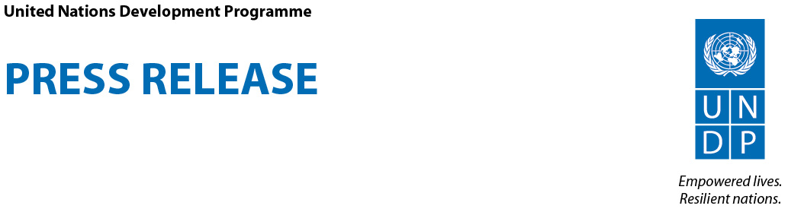

Celebrities join UNDP video on sustainable development

New York, 6 June 2012—United Nations Development Programme (UNDP) launched today a video spot “The Future We Want” which uses voices of Spanish actor Antonio Banderas, French actor Lambert Wilson, Brazilian football star Marta Vieira da Silva and Italian actress Laura Morante, to explain what sustainable development is to mainstream audiences.

The public service announcement will be part of the “Future We Want” campaign of the United Nations ahead of the Conference on Sustainable Development, or ‘Rio+20,’ to be held in Brazil on 20-22 June 2012.

The video aims at explaining the foundation of sustainable development planning, i.e., each policy and investment decision must take into equal consideration its economic, social and environmental impacts.
It has become common practice that government and private sector decision making mainly takes into account the economic gains of any policy or investment, which often leads to the neglect of the poor and overexploitation of the environment.
“For me, achieving sustainable development is not about trading economic, social, and environmental objectives off against each other,” said Helen Clark, UNDP Administrator. “It is about seeing them as interconnected objectives which are best pursued together.”
It has been a challenge for many political leaders, activists, researchers and spokespeople to explain what sustainable development stands for. The new spot attempts to portray the topic in a way that everybody can understand.
The video, using the hand painting and stop motion technique, was created by Italian video artist Virgilio Villoresi, under the artistic direction of Luca Cipelletti from AR.CH.IT. It is available for any broadcaster, and will be posted on YouTube, on United Nations web sites, and internet sites of partner organizations before and during the ‘Rio+20’ conference.

The video spot also invites the public to vote on 100 recommendations on sustainable development at http://vote.riodialogues.org. The recommendations have been put forward by a community of experts who convened online at the Rio+20 Dialogues, organized by the Government of Brazil on a social networking web site developed by UNDP. The top recommendations based on public votes will be presented to the more than 100 heads of state and government participating in Rio+20 Conference.
To see the video spot, visit http://undp.org/rio
Broadcasters can access high-quality versions of the video spot here: http://web.undp.org/broadcast/rio+20-psa/the-future-we-want/

******

For more information, please contact:

New York: Stanislav Saling Tel.: +1 212 906 5296, stanislav.saling@undp.org

Geneva: Aziyadé Poltier-Mutal; Tel: +41-22-917-8368; aziyade.poltier@undp.org

For broadcast footage, please contact Boaz Paldi, +1 212 906 6801, boaz.paldi@undp.org

For Rio Dialogues, contact Alberto Lizzi, +1 212 906 5332, alberto.lizzi@undp.org
_____________________________________________
UNDP partners with people at all levels of society to help build nations that can withstand crisis, and drive and sustain the kind of growth that improves the quality of life for everyone. On the ground in 177 countries and territories, we offer global perspective and local insight to help empower lives and build resilient nations. www.undp.org. Follow us on twitter and facebook.

